EVENTS SCHEDULE

DAY 1(FRIDAY)

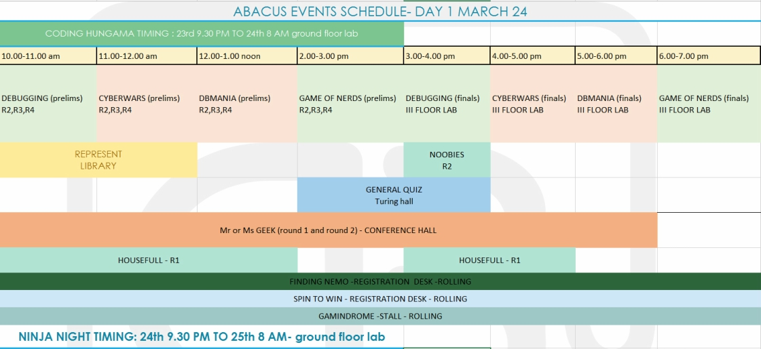

DAY 2(SATURDAY)

